Practical #7
Practical Title:
To understand automated testing concepts and Selenium architecture for web applications
Theory:
1. What is Automated Testing?
Automated testing is a technique where test cases are executed using tools and scripts instead of manual effort.
It helps in:
- Faster testing
- Repeated execution
- Improved accuracy

2. What is Selenium?
Selenium is an open-source tool used for automating web applications for testing purposes.
It supports multiple languages like:
- Python
- Java
- C#

3. Selenium Components

Selenium IDE:
- Browser extension
- Record and playback testing
- Easy for beginners

Selenium WebDriver:
- Core component
- Directly interacts with browser
- Supports automation using code

Selenium Grid:
- Used for parallel testing
- Runs tests on multiple machines/browsers
- Saves time

4. Selenium Architecture
Selenium architecture consists of:
- Test Script → Written in language (Python/Java)
- WebDriver API → Sends commands
- Browser Driver (ChromeDriver, GeckoDriver)
- Browser → Executes actions
Flow:
Test Script → WebDriver → Browser Driver → Browser

Procedure:
Step 1: Install Selenium and required dependencies
Step 2: Setup WebDriver
Step 3: Write a simple test script
Step 4: Perform actions (click, input, etc.)
Step 5: Execute the test script
Output Screenshots:
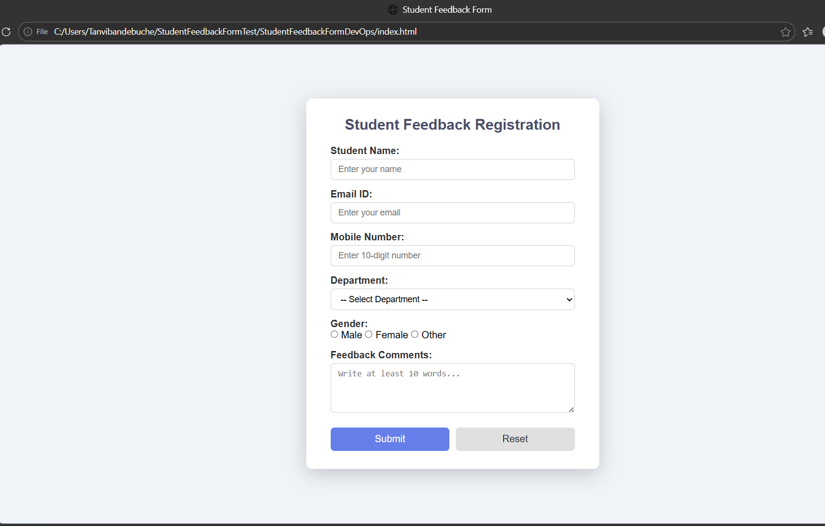
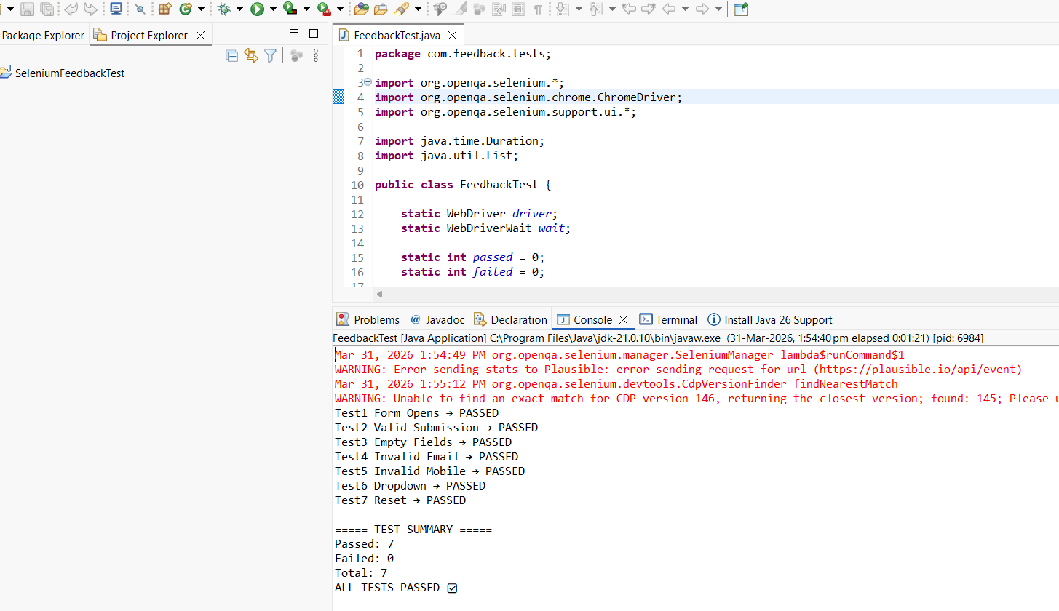

Activity / Task:
Task 1: Selenium Script
Code :
package com.selenium.test;
import org.openqa.selenium.By;
import org.openqa.selenium.WebDriver;
import org.openqa.selenium.chrome.ChromeDriver;
import org.openqa.selenium.support.ui.WebDriverWait;
import org.openqa.selenium.support.ui.ExpectedConditions;
import java.time.Duration;
public class FirstPro {
public static void main(String[] args) {
WebDriver driver = new ChromeDriver();
driver.manage().window().maximize();
driver.get("http://localhost:5500/");
WebDriverWait wait = new WebDriverWait(driver, Duration.ofSeconds(10));
try {
wait.until(ExpectedConditions.visibilityOfElementLocated(
By.xpath("//input[@placeholder='Enter your email']")
));
driver.findElement(By.xpath("//input[@placeholder='Enter your email']"))
.sendKeys("maheenmeshr.2115@gmail.com");
driver.findElement(By.xpath("//input[@placeholder='Enter your password']"))
.sendKeys("12345678");
driver.findElement(By.xpath("//button[contains(text(),'Sign In')]"))
.click();
wait.until(ExpectedConditions.urlContains("dashboard"));
Thread.sleep(10000);
if (driver.getCurrentUrl().contains("dashboard")) {
System.out.println(" LOGIN SUCCESSFUL - TEST PASSED");
} else {
System.out.println(" LOGIN FAILED - TEST FAILED");
}
} catch (Exception e) {
System.out.println(" LOGIN FAILED - TEST PASSED");
}
driver.quit();
}
}
Task 3: Advantages of Automated Testing over Manual Testing
- Faster execution
- Reusable test scripts
- More accurate (less human error)
- Supports continuous testing (CI/CD)
- Saves time in long run

Advantages
- Fast and efficient testing
- Supports multiple browsers
- Reduces manual effort
- Reusable scripts
- Integration with CI/CD

Challenges
- Initial setup complexity
- Requires programming knowledge
- Maintenance of test scripts

